Tasks

Objective Questions:

- What is the total no. of tables present in the data?
Answer: There are 2 tables present in the data are as follows:
- raw data
- country description

- What is the total no. of attributes present in the data?
Answer: There are 21 attributes present in sheet 1 and 2 attributes are there in sheet 2. Hence, the total no of attributes present in the data is 23.

- How many categorical columns are there in the data? [Search about categorical and continuous data, and try to answer this question]
Answer: Categorical data is the data with non-numerical value and there are 12 columns with non-numerical value. These are as follows:
- RestaurantName
- City
- Address
- Locality
- LocalityVerbose
- Cuisines
- Currency
- Has_Table_Booking
- Has_Online_Booking
- Is_delivering_now
- Switch_to_order_menu
- Datekey_Opening

- The data consists of some inconsistent and missing values so ensure that the data used for further analysis is cleaned.
Answer:
- Identify and remove duplicates rows.
- Identify the missing cells using find and replace. Replace the cell with the “0” for numeric data and replace the non-numerical data with “not available”.
- Look for the spelling error and correct it with find and replace.
- Use trim function to remove extra spaces.

- Using the LookUp functions, fill up the countries in the original data using the country code.
Answer:
- Click anywhere on the data sheet 1.
- Add a new column and name it as “Country” and use Vlookup formula.
=VLOOKUP(C2,'country description'!$A$2:$B$16,2)

- Create a table to represent the number of restaurants opened in each country.
Answer:
- Click anywhere on the data.
- Insert Pivot table in the existing sheet.
- Add Country in row field.
- Add RestaurantID in value field and in value setting make the value as count.

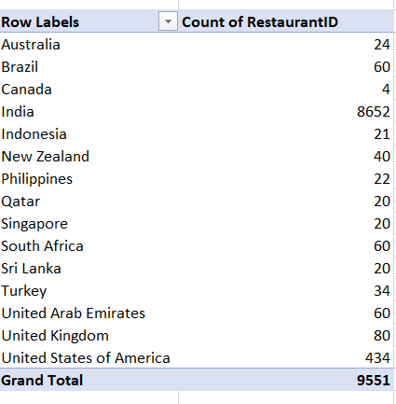

- Also, the management wants to look at the number of restaurants opened each year, so provide them with something here.
Answer: We can identify the no. of restaurants opened in each year using pivot table and chart.
- Click anywhere on the data.
- Insert Pivot Table in the existing sheet.
- Add Opening_year in row field.
- Add RestaurantID in value field and in filed value setting make it as count.

Table & Visualization:
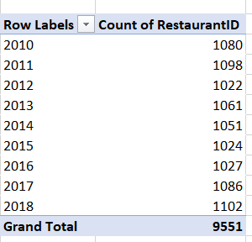

Observation:
- The above chart shows the number of restaurants opened each year, where the highest number of restaurants opened in initial years.
- The number of new restaurants showed a declining trend from a peak in 2011 to a low point in 2015.
- Following 2016, there was improvement in the number of new restaurants.
- What is the total number of restaurants in India in the price range of 4?
Answer: There is a total of 387 restaurants in the price range of 4. We can find-out the total no. of restaurants in India in the price range of 4 using countifs function.
- Use countifs function.
- Select the range of the country and equate it with India.
- Select the price range and equate it with 4.
- Use this formula to find out total restaurants in India in the price range of 4
- =COUNTIFS('Raw Data'!H:H,"India",'Raw Data'!R:R,4)

- What is the average number of voters for the restaurants in each country according to the data?
Answer:
- Click on anywhere on the data.
- Insert Pivot table in the existing sheet.
- Add Country in row field.
- Add the votes in value filed and in field value setting make it as average.

Table & Visualization:
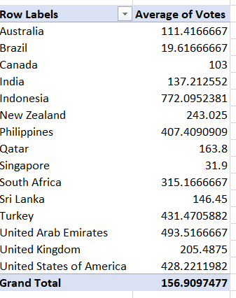

Observation:
- Country with lower average: Country with the shorter bars, like Brazil, Canada, Singapore, etc indicate lower average of votes.
- Country with higher average: Country with the longer bars, like Indonesia, Philippines, Turkey, UAE and USA indicate higher average of votes.

- Calculate the average rating for all the restaurants that have price_range < 4 and provide online delivery. Use only the “IF” function, Logical Operators, and Aggregation functions to solve this problem. [Note: Don’t use Conditional aggregation in this question.]
Answer: 3.273
- Use if function along with average by selecting price range less than 4 and has online delivery.
- And return average of rating in the result range for all the restaurants by clicking Ctrl+Shift+Enter.
- Formula: =AVERAGE(IF(('Raw Data'!R2:R9552<4)*('Raw Data'!O2:O9552="Yes"),'Raw Data'!X2:X9552))

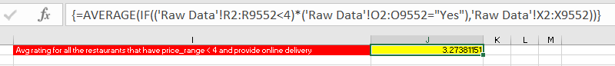
- Using Conditional formatting highlight the rows of restaurants that are located in the countries or cities that you’ve suggested to the management for opening new restaurants.
Answer:
- Select the entire data sheet.
- Go to conditional formatting->New rule->Use a formula to determine which cells to format.
- use the formula: =or($D2=”Dubai”,$D2=”Jakarta”) . {since these 2 countries are suggested for opening new restaurants}

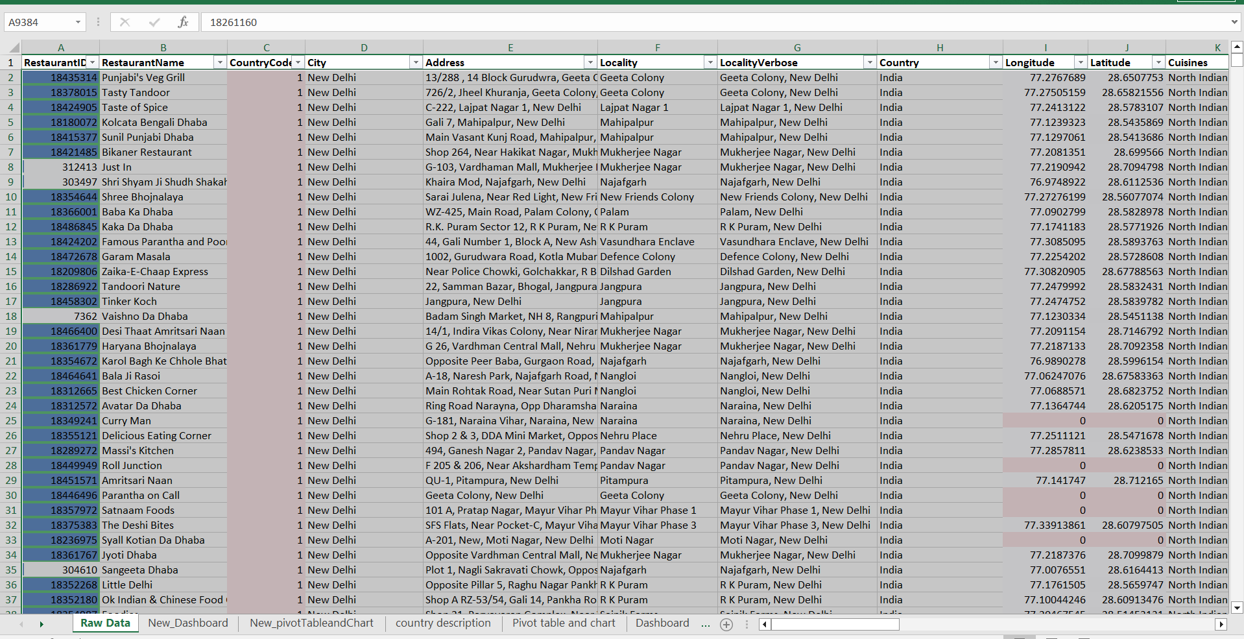

- Create a new customized price column that consists of the abbreviation/symbol of the currency along with the Average_cost_for_two value. [Use string operations to do this task]
Answer:
- Insert a new column and named it as Customized Price and enter the below formula.
- Formula: =MID(L2,FIND("(",L2)+1,LEN(L2)-FIND("(",L2)-1)&" "&T2
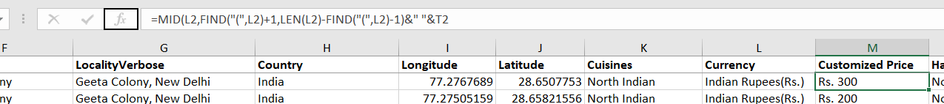
- How can you create an array formula in Excel or Google Sheets to count the number of restaurants listed that do not offer online delivery, are in the lowest price range, and have an average cost for two people less than or equal to 250 Indian Rupees?
Answer: 1694
- Select a cell, use sum formula.
- Select range of has_Online_delivery and make it as No in formula.
- Select range of price range of 1.
- Select the average_cost_for_two and make it less than 250 in the formula.
- To make this formula array, after entering the below formula click Ctrl+Shift+Enter.
- Formula: =SUM(('Raw Data'!O2:O9552="No")*('Raw Data'!R2:R9552=1)*('Raw Data'!W2:W9552<=250))
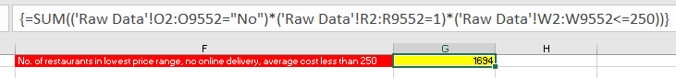

Subjective Question:

- Suggest a few countries where the team can open newer restaurants with lesser competition. Which visualization/technique will you use here to justify the suggestions?

Approach:
- Use a pivot table to show the count of restaurants and average rating per country.
- Display the distribution with the help of clustered bar chart for comparing the countries which are suitable to open new restaurants.

Table & Visualization:

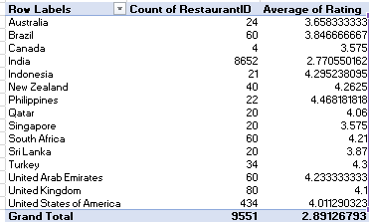

Insights:
- Higher Average: Countries like Philippines, Indonesia, UAE and USA have higher average of rating but have low number of restaurants.
- Lower Average: Countries like India, Singapore and Sri Lanka have lower average rating but have more room for healthy competition.

Recommendations:
- Lock onto the Philippines and Indonesia, which have the highest satisfaction level by consumers, with 4.47 and 4.29 ratings, respectively, while their competition is amazingly low at only 21–22 restaurants.
- Target the "High Quality, Low Supply" Gap: New Zealand and Turkey come into focus, with strong average ratings above 4.2 and a small footprint of less than 40 restaurants, indicative of a ready market for high-standard dining.
- Operational Overhaul for India: Since it hosts more than 90% of the restaurant count, amounting to 8,652, and has the lowest average rating at 2.77, this location requires more quality control and service training rather than new openings in order to protect the brand's global reputation.

- Come up with the names of States and cities in the suggested countries suitable for opening restaurants.

Approach:
- Use a pivot table to show the sum of rating and average of votes of cities of suggested countries by filtering the city from suggested countries by adding a slicer and selecting the country in slicer, select the country like UAE, Philippines and Indonesia.
- Use a clustered bar chart to show the distribution of the average of ratings, sum of votes across cities of suggested countries.

Table & Visualization:

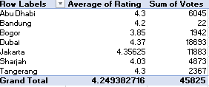

Insights:
- Higher Average Ratings: Cities like Dubai, Abu Dhabi, Jakarta and Tangerang have the highest average rating among the cities.
- Higher sum of Votes: Cities like Dubai, Jakarta and Abu Dhabi have the higher sum of votes.

Recommendations:
- Scale High-Performers: Marketing resources should be invested in Dubai and Jakarta because they seem to prove that with a huge number of customers, it is possible to attain high ratings.
- Invest Bandung: This one seems to be a "hidden gem," rated well at 4.2 but with critically low visibility of just 22 total votes. Consider running an awareness campaign here in particular.
- Audit Bogor: Bogor is your poorest performer with a rating of 3.85; you therefore need to audit service quality issues as a matter of urgency to prevent any further damage to the brand name in that particular location.

- According to the countries you suggested, what is the current quality regarding ratings for restaurants that are open there?

Approach:
- Use a pivot table to find the average rating of each country and analyse the rating of suggested countries.
- Use a column chart to show the distribution of average rating of each country.
Table & Visualization:
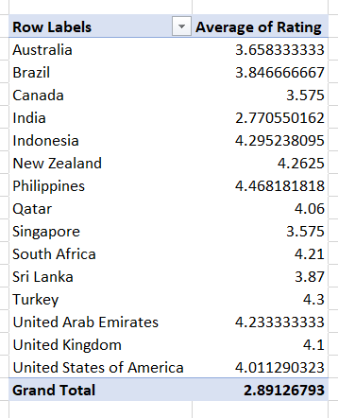

Insights:
- High Performers Hub: The Philippines and Indonesia are the top performers among the 15 countries, with the highest average ratings of 4.46 and 4.29 respectively.
- Low Performers Area: The country which has the lowest average rating is India with the rating of 2.77, which is low as compared to others.
Recommendations:
- Standardize Quality Across Tier-1 Markets: There is a significant difference among nations like the UK with 4.10, Canada/Singapore with 3.575. Seek to close this gap by standardizing training and operations so that there is consistency in consumer brand experience across these regions.
- Research on Performance Gap in India: Currently, in India, we have the lowest average rating, i.e., 2.77, even lower than our grand total, i.e., 2.89, as well as lower ratings compared to others in that area. There should be a root cause analysis in that area, i.e., whether it’s because of service quality, or localization of products, or price.

- Also, what is the current expenditure on food in the suggested countries, so we can keep our financial expenditure in control?

Approach:
- Use a pivot table to find the average expenditure on food in each country and analyse the expense of suggested countries.
- Use an area chart to show the distribution of average expenditure of each country in suggested countries.

Table & Visualization:
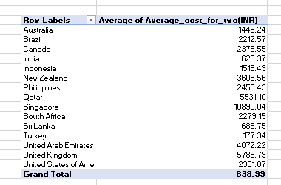

Insights:
- Lower expenditure: The countries like India, Turkey and Sri Lanka have the lowest average expenditure it means that the people spend less on food in these countries.
- Higher expenditure: The countries like Singapore, United Kingdom and Qatar have the highest average expenditure it means the people spend more on food in these countries.

Recommendations:
- Target High-Paying Market with Strong Spending Ability: Based on your analysis of average cost, Singapore, where Avgerage Cost = 10,890.04 INR, and United Kingdom, where Avgerage Cost = 5,785.79 INR, are considered to be the most promising markets, as in both areas people are already spending heavily on high-end dining.
- Targeting cities located in high-rating growth states: You can target cities located in countries like the USA or UAE with high "Average of Rating," as it implies a quality-expectancy customer group that appreciates quality businesses with higher city ratings.
- Balance Competition Density with Quality Gaps: Referring back to your "Count of RestaurantID" data set, try to pinpoint areas with moderately high levels of competition while still yielding high ratings that may be indicative of an appeal for high-quality options rather than budget-oriented options only.

- Come up with the names of restaurants from the recommended states that are our biggest competitors and also those that are rated in the lower brackets, i.e. 1-2 or 2-3.

Approach:
- Use a pivot table to show the average rating of each restaurant.
- Filter the data using top 10 Restaurant Name by Average of Rating.
- Filter the data using bottom 10 Restaurant Name by Average of Rating.

Table & Visualization:
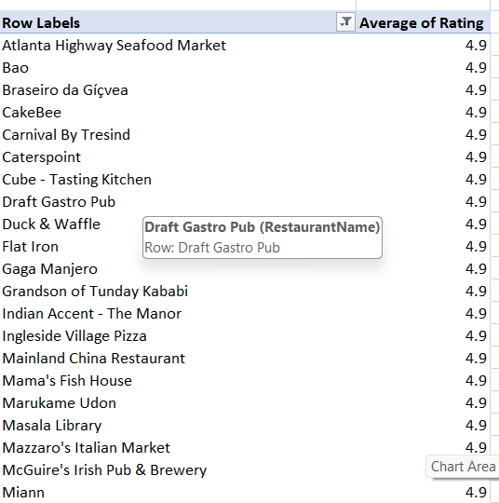
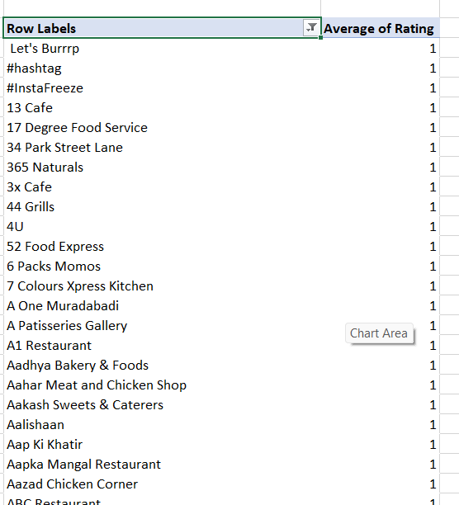
Insights:
- Higher Customer Satisfaction: There are many restaurants come in higher rating of 4.9 which includes CakeBee, FlatIron, Miann, etc. This makes them more competitive among themselves in terms of customer satisfaction.
- Lower Customer Satisfaction: Restaurants like Aalishaan, 4U, 13 Cafe, etc have lowest rating of just 1 among the restaurants.

Recommendations:
- High Average Restaurants Should Maintain Quality: As we have seen from the past most restaurants do not maintain that quality over a period of time. So, they should focus on maintaining what has done right for them.
- Low Average Restaurants Should Improve Quality: Many restaurants are not providing good quality cuisines, which will make them less competitive. They should enhance the quality of their food in order to be in the race of restaurant market.

- Which cuisines should we focus on in the newer restaurants to get better feedback? Does the choice of cuisines affect the restaurant ratings?

Approach:
- Use a pivot table to show the count of restaurants and average rating in terms of the cuisines.
- Filer the data using top 10 cuisines by count of restaurant. So, that we can analyse the average rating of cuisines which can be further analyse for getting better feedback.
- Use a combo chart to display the restaurant’s count and average rating of cuisines.

Table & Visualization:
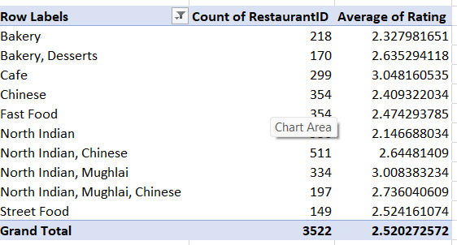

Insights:
- High Competition, Low Satisfaction: North Indian and North Indian, Chinese cuisine dominate the market in terms of number of restaurants. However, these cuisine’s categories have lower ratings (around 2.1 to 2.6). This suggests a “quantity over quality trend.
- Underperforming Niches: Street food and bakery have low restaurant counts but still struggle with low ratings (around 2.3-2.5). This suggests these categories lack quality.

Recommendations:
- Focused on Specialized Niches: Avoid the cuisine like generic North Indian and go for cuisines bakery & Desserts model. Since it has the decent ratings and it has less competition.
- Hybrid Cuisines Strategy: The North India, Mughlai cuisine has decent balance of count (334) and average rating (2.7). Combining North Indian with Mughlai or Chinese cuisine will elevate customer satisfaction.

- According to our current data, should we go for online delivery and table booking? Does that affect the customer’s ratings?

Approach:
- Use a pivot table to find the average of rating and count of RestaurantID of the restaurants which provide online delivery as well as for the restaurants that do not provide online delivery.
- Use a pie chart to show the distribution of average rating and count of RestaurantID of the restaurants providing online delivery as well as for the restaurants that do not provide online delivery.
- Use a pivot table to find the average of rating and count of RestaurantID of the restaurants which provide table booking as well as for the restaurants which have table booking.
- Use a pie chart to show the distribution of average rating and count of RestaurantID of the restaurants providing table booking as well as for the restaurants which have table booking.

Table & Visualization:
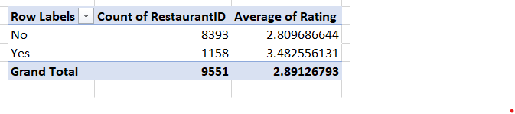

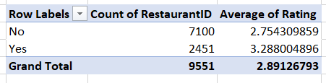

Insights:
- Impact of Online Delivery: Restaurants that provide online delivery have a higher customer satisfaction (3.288) as compared to that doesn’t provide online delivery (2.75).
- Table Booking Boosts Ratings: The pie chart clearly indicates that the restaurants that have table booking, they have higher average rating (3.48) and the restaurants that don’t have table booking lacks in customer satisfaction (2.80)

Recommendations:
- Expand Restaurants providing online delivery: The new restaurants should focus on providing online delivery, as the chart indicates it has great impact on customer satisfaction.
- Implement Table Booking: The data shows that the people are more satisfied with the restaurants providing table booking. This will help in customer satisfaction.

- Should the team keep the rate of cuisines higher? Will that affect the feedback? According to our data are the rates of cuisines and ratings, correlated?

Approach:
- Use a pivot table to show the count of restaurant and average cost in different ratings.
- Use the clustered column chart to show the distribution of count of restaurant and average cost in terms of the rating.

Table & Visualization:
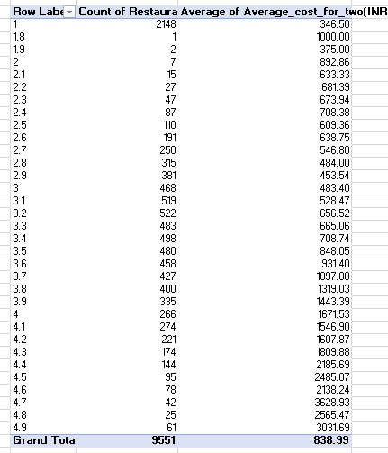

Insights:
- Positive Correlation between Ratings and Cost: As we can see from the chart as the average cost increases, the average rating also increases. It means both the values have positive impact on each other.
- Negative Correlation Between Ratings and Volume: As the count of restaurants increase, the average rating decreases. This makes the negative impact on each other.

Recommendations:
- Quality over Quantity: To improve the feedback, one should focus on increasing the average cost. As, we have seen it has positive impact on customer satisfaction.
- Do Not Keep Higher Rate for All Cuisines: The team should not keep the rate of cuisines higher in the region where there are more restaurants. Because the region in which the count of restaurant is higher, that region has received poor feedback from the consumer.
- What is the distribution of the number of restaurants of different price ranges in all the countries?

Approach:
- Use a pivot table to show the number of restaurants in each country in different price ranges.
- Use stack bar to show the distribution of restaurants in different price ranges.

Table & Visualization:
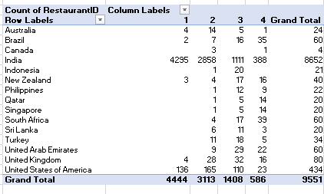

Insights:
- Extreme market Imbalance: As we can see from the dataset, India is the primary market for the restaurants. India occupied nearly 90% of the restaurant market. So, new strategy should be implemented in order to attract more consumer from the global market.
- Indonesia’s Mid-Market Trap: Indonesia is the only country in which 95% of the total restaurants come in the mid-price range of 3.
- The hub of luxury restaurants: Singapore and Qatar have almost 70 % of the total restaurants in the price range of 4.

Recommendations:
- Aggressive Quality Control: Since, India has the bulk of the business, and has the lowest rating, it is recommended to increase 10% increase in India’s average rating would lift global “Grand Total” more than a 100% improvement in any other country.
- Exploit the Indonesia gap: Focus on launching “Price Range 2” and “Price Range 4” restaurants in Indonesia. As, the bulk of the restaurants are in the price range of 3. It will provide more opportunity for the other price range restaurants.

- Explain your approach in brief for suggesting countries/cities in order to open new restaurants, if the objective and subjective questions would have not been given to assist you. [you have to give bullet pointers in order to answer this question]

Approach:
  - Go through the whole dataset: Firstly, in order to understand the data, you have to familiar with the dataset, so I had gone through the whole dataset while approaching the project. Read all the attributes and take a look at all the tables.
  - Clean the data: After understanding the dataset, clean the data according to the result you wanted. For e.g. remove all the extra spaces from the dataset. Check the format of all the attributes and change the format if needed. Check the spelling and replace the spelling errors using find and replace. Check for the null values and replace them with suitable value like mean, median or mode for numerical column or replace with “Not Available” for non-numerical column.
  - Create pivot table and charts: To find the cities or the countries suitable for opening new restaurants, create pivot table and chart. You can find the cities or the countries by having the data like average rating, count of restaurant, average cost for two.
  - Analyse the chart and the table: Analyse the chart and find the cities or the countries with the possibility of opening new restaurants.
  - Identify City or country with less restaurants: Look for the city or the country which has lower number of restaurants, so there is less competition.
  - Identify City or Country with most average rating: Look for the country or the city with highest average rating, it means that the people are interested in the restaurants of that particular city.
  - Identify City or Country with high average cost per two: Look for the country or the city with highest average per cost two, it means the people of that area are keen to spend more on the food.

